**Sandeep Sir Java Assignment 3**

1.

**Code**

**package** Loan;

**import** java.util.Scanner;

**public** **class** Loan {

**public** **static** **void** main(String[] args) {

Scanner scanner = **new** Scanner(System.***in***);

System.***out***.print("Enter the loan amount (Principal) in ₹: ");

**double** principal = scanner.nextDouble();

System.***out***.print("Enter the annual interest rate (in %): ");

**double** annualInterestRate = scanner.nextDouble();

System.***out***.print("Enter the loan term (in years): ");

**int** loanTerm = scanner.nextInt();

**double** monthlyInterestRate = annualInterestRate / 12 / 100;

**int** numberOfMonths = loanTerm * 12;

**double** monthlyPayment = principal * (monthlyInterestRate * Math.*pow*(1 + monthlyInterestRate, numberOfMonths))

/ (Math.*pow*(1 + monthlyInterestRate, numberOfMonths) - 1);

**double** totalAmountPaid = monthlyPayment * numberOfMonths;

System.***out***.printf("Your monthly payment is: ₹%.2f%n", monthlyPayment);

System.***out***.printf("Total amount paid over the life of the loan: ₹%.2f%n", totalAmountPaid);

}

}

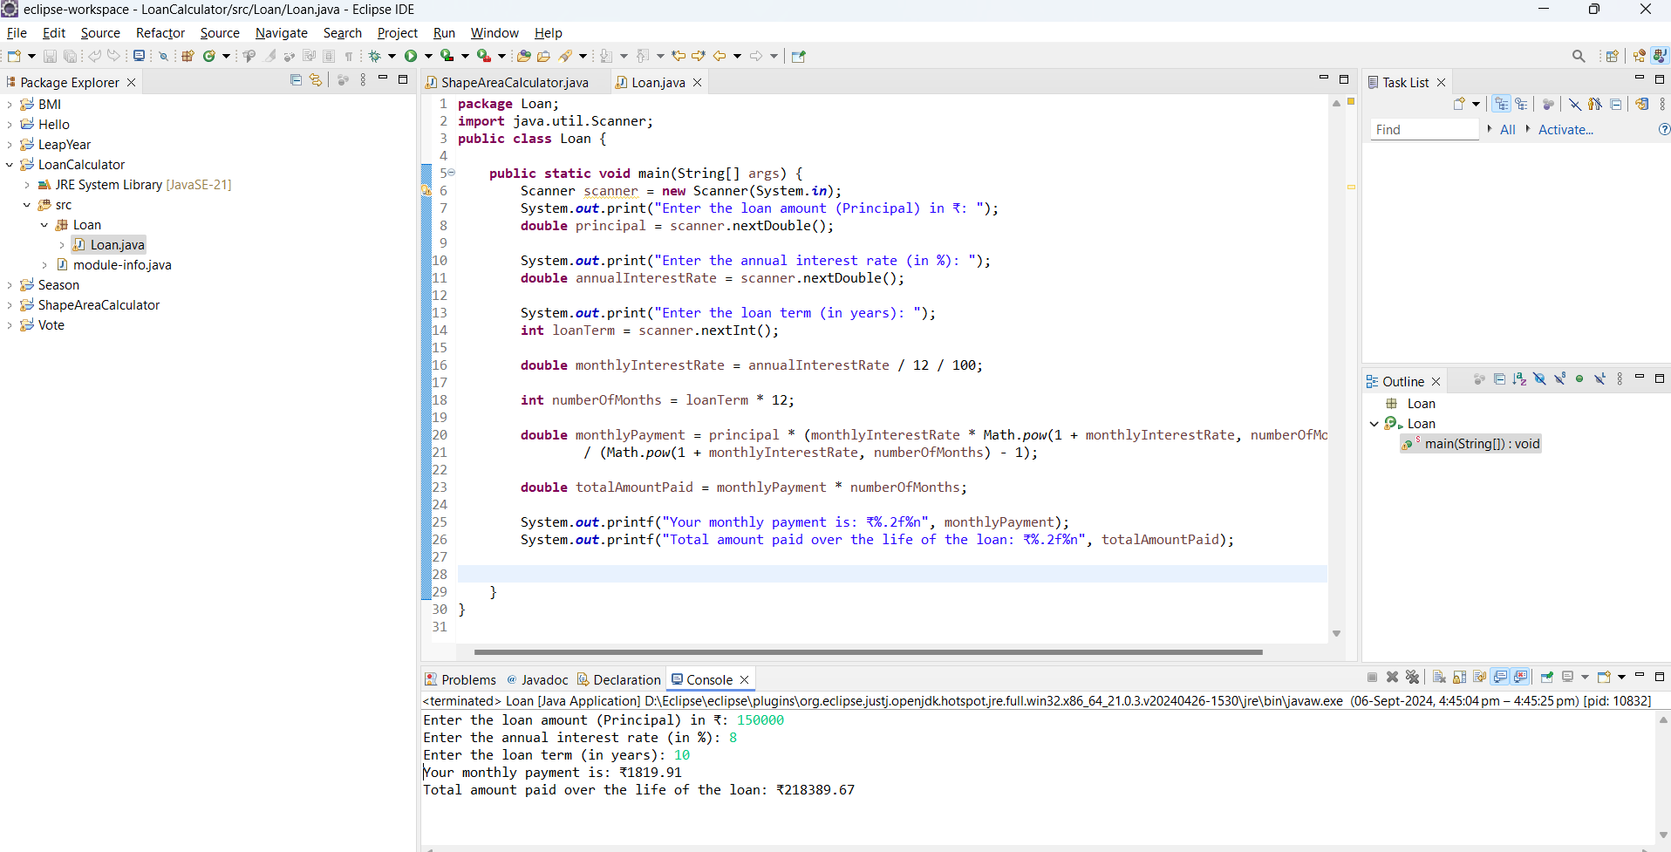

2.

**Code**

**package** CompoundInterestCalculator;

**import** java.util.Scanner;

**class** CompoundInterestCalculator {

**private** **double** principal;

**private** **double** annualInterestRate;

**private** **int** numberOfCompounds;

**private** **int** years;

**private** **double** futureValue;

**private** **double** totalInterest;

**public** **void** acceptRecord() {

Scanner scanner = **new** Scanner(System.***in***);

System.***out***.print("Enter the initial investment amount (Principal) in ₹: ");

principal = scanner.nextDouble();

System.***out***.print("Enter the annual interest rate (in %): ");

annualInterestRate = scanner.nextDouble();

System.***out***.print("Enter the number of times the interest is compounded per year: ");

numberOfCompounds = scanner.nextInt();

System.***out***.print("Enter the investment duration (in years): ");

years = scanner.nextInt();

}

**public** **void** calculateFutureValue() {

**double** ratePerPeriod = annualInterestRate / numberOfCompounds / 100;

**int** totalNumberOfPeriods = numberOfCompounds * years;

futureValue = principal * Math.*pow*(1 + ratePerPeriod, totalNumberOfPeriods);

totalInterest = futureValue - principal;

}

**public** **void** printRecord() {

System.***out***.printf("Future Value of the investment: ₹%.2f%n", futureValue);

System.***out***.printf("Total Interest Earned: ₹%.2f%n", totalInterest);

}

**public** **static** **void** main(String[] args) {

CompoundInterestCalculator calculator = **new** CompoundInterestCalculator();

calculator.acceptRecord();

calculator.calculateFutureValue();

calculator.printRecord();

}

}

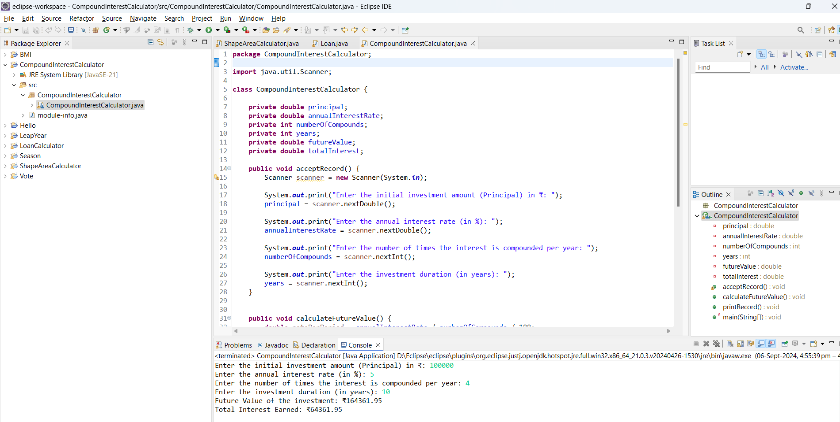

3.

**Code**

**package** BMITracker;

**import** java.util.Scanner;

**class** BMITracker {

**private** **double** weight;

**private** **double** height;

**private** **double** bmi;

**private** String classification;

**public** **void** acceptRecord() {

Scanner scanner = **new** Scanner(System.***in***);

System.***out***.print("Enter your weight (in kilograms): ");

weight = scanner.nextDouble();

System.***out***.print("Enter your height (in meters): ");

height = scanner.nextDouble();

}

**public** **void** calculateBMI() {

bmi = weight / (height * height);

}

**public** **void** classifyBMI() {

**if** (bmi < 18.5) {

classification = "Underweight";

} **else** **if** (bmi >= 18.5 && bmi < 24.9) {

classification = "Normal weight";

} **else** **if** (bmi >= 25 && bmi < 29.9) {

classification = "Overweight";

} **else** {

classification = "Obese";

}

}

**public** **void** printRecord() {

System.***out***.printf("Your BMI is: %.2f%n", bmi);

System.***out***.println("BMI Classification: " + classification);

}

**public** **static** **void** main(String[] args) {

BMITracker tracker = **new** BMITracker();

tracker.acceptRecord();

tracker.calculateBMI();

tracker.classifyBMI();

tracker.printRecord();

}

}

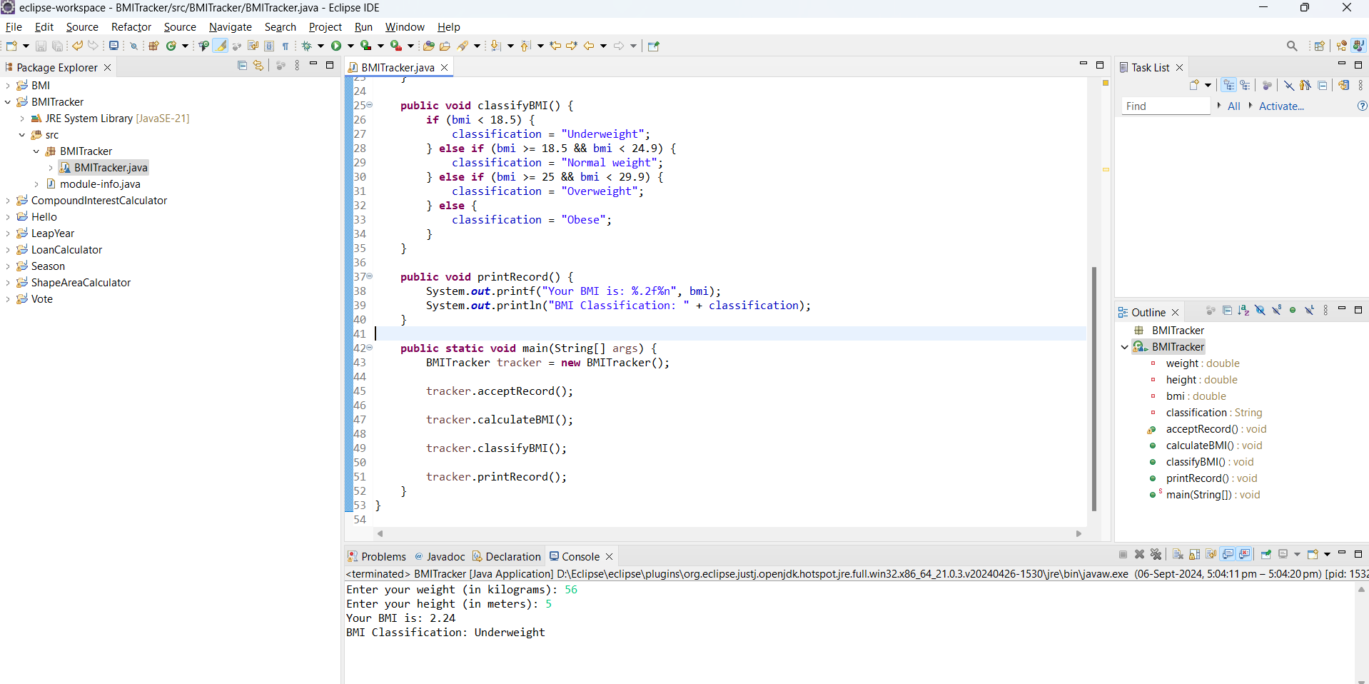

4.

Code

**package** discountCalculator;

**import** java.util.Scanner;

**class** DiscountCalculator {

**private** **double** originalPrice;

**private** **double** discountRate;

**private** **double** discountAmount;

**private** **double** finalPrice;

**public** **void** acceptRecord() {

Scanner scanner = **new** Scanner(System.***in***);

System.***out***.print("Enter the original price of the item in ₹: ");

originalPrice = scanner.nextDouble();

System.***out***.print("Enter the discount percentage: ");

discountRate = scanner.nextDouble();

}

**public** **void** calculateDiscount() {

discountAmount = originalPrice * (discountRate / 100);

finalPrice = originalPrice - discountAmount;

}

**public** **void** printRecord() {

System.***out***.printf("Discount Amount: ₹%.2f%n", discountAmount);

System.***out***.printf("Final Price after Discount: ₹%.2f%n", finalPrice);

}

**public** **static** **void** main(String[] args) {

DiscountCalculator calculator = **new** DiscountCalculator();

calculator.acceptRecord();

calculator.calculateDiscount();

calculator.printRecord();

}

}

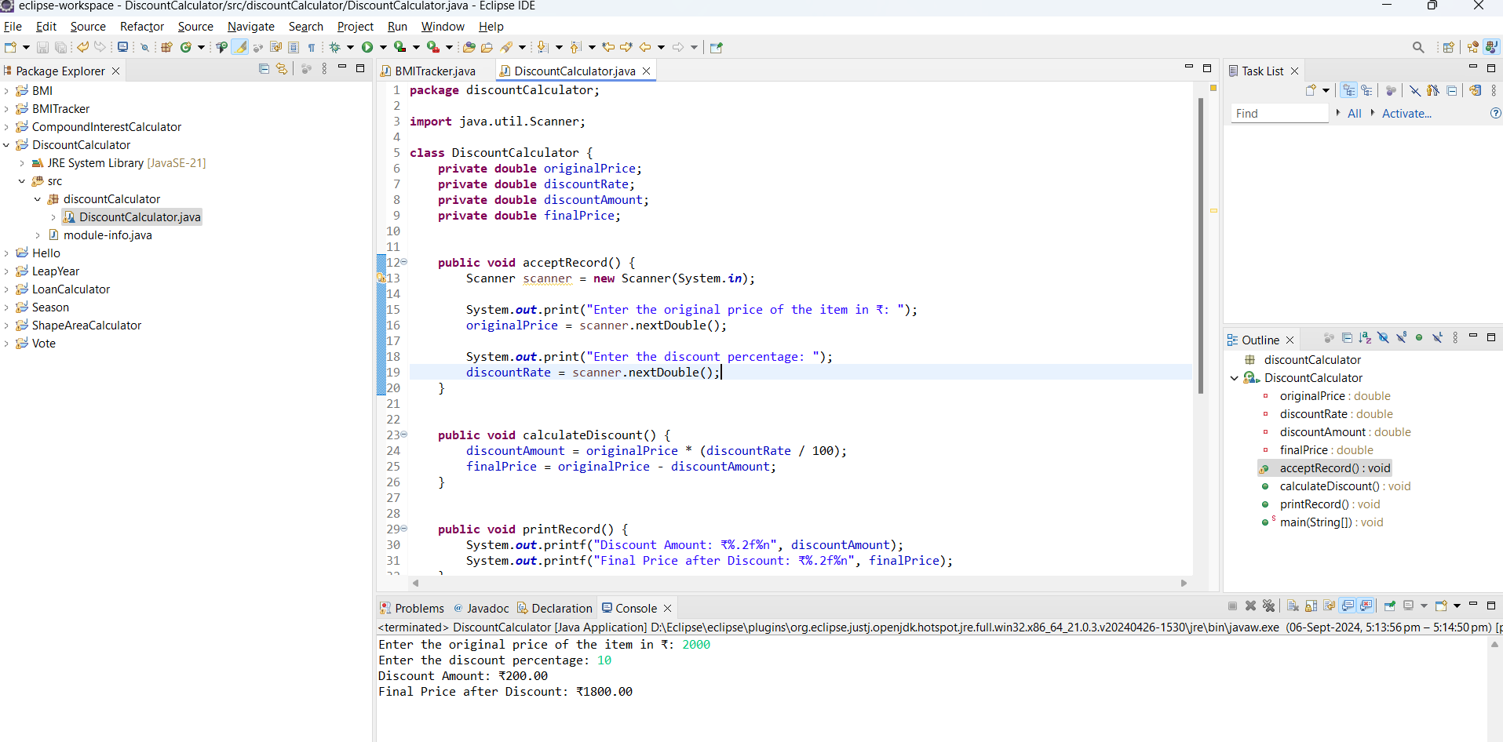

5.

**Code**

**package** tollbooth;

**import** java.util.Scanner;

**class** TollBooth {

**private** **double** carRate;

**private** **double** truckRate;

**private** **double** motorcycleRate;

**private** **int** numberOfCars;

**private** **int** numberOfTrucks;

**private** **int** numberOfMotorcycles;

**private** **double** totalRevenue;

**public** **void** setTollRates() {

Scanner scanner = **new** Scanner(System.***in***);

System.***out***.print("Enter the toll rate for Cars in ₹: ");

carRate = scanner.nextDouble();

System.***out***.print("Enter the toll rate for Trucks in ₹: ");

truckRate = scanner.nextDouble();

System.***out***.print("Enter the toll rate for Motorcycles in ₹: ");

motorcycleRate = scanner.nextDouble();

}

**public** **void** acceptVehicleCounts() {

Scanner scanner = **new** Scanner(System.***in***);

System.***out***.print("Enter the number of Cars passing through the toll booth: ");

numberOfCars = scanner.nextInt();

System.***out***.print("Enter the number of Trucks passing through the toll booth: ");

numberOfTrucks = scanner.nextInt();

System.***out***.print("Enter the number of Motorcycles passing through the toll booth: ");

numberOfMotorcycles = scanner.nextInt();

}

**public** **void** calculateTotalRevenue() {

totalRevenue = (numberOfCars * carRate) + (numberOfTrucks * truckRate) + (numberOfMotorcycles * motorcycleRate);

}

**public** **void** printReport() {

**int** totalVehicles = numberOfCars + numberOfTrucks + numberOfMotorcycles;

System.***out***.println("Total number of vehicles: " + totalVehicles);

System.***out***.printf("Total revenue collected: ₹%.2f%n", totalRevenue);

}

**public** **static** **void** main(String[] args) {

TollBooth booth = **new** TollBooth();

booth.setTollRates();

booth.acceptVehicleCounts();

booth.calculateTotalRevenue();

booth.printReport();

}

}

